A PROPOSED IMPLEMENTATION OF FRONT END BASED WEBSITE FOR MONITORING PILLS

**A PROJECT REPORT**

###### ***Submitted by***

**Smitesh Somkuwar (20BCE10355)**

**Tejas Gawali (20BCE10360)**

**Aryan Singh (20BCE10843)**

**Khush Bubna (20BCE10798)**

**Areeb Ahmad Siddiqui (20BCE11049)**

*in partial fulfillment for the award of the degree*

*of*

**BACHELOR OF TECHNOLOGY**

*in*

# **COMPUTER SCIENCE AND ENGINEERING**



**SCHOOL OF COMPUTING SCIENCE AND ENGINEERING**

**VIT BHOPAL UNIVERSITY**

**KOTHRIKALAN, SEHORE**

**MADHYA PRADESH – 466114**

DEC 2021

**VIT BHOPAL UNIVERSITY, KOTHRIKALAN, SEHORE**

**MADHYA PRADESH – 466114**

**BONAFIDE CERTIFICATE**

Certified that this project report titled **“……….TITLE OF THE PROJECT……………..”** is the bonafide work of “**…NAME OF THE CANDIDATES. (Register No :)”** who carried out the project work under my supervision. Certified further that to the best of my knowledge the work reported at this time does not form part of any other project/research work based on which a degree or award was conferred on an earlier occasion on this or any other candidate.

**PROGRAM CHAIR PROJECT GUIDE**

School of Computer Science and Engineering School of Computer Science and Engineering

VIT BHOPAL UNIVERSITY VIT BHOPAL UNIVERSITY

The Project Exhibition I Examination is held on _______________

**ACKNOWLEDGEMENT**

First and foremost I would like to thank the Lord Almighty for His presence and immense blessings throughout the project work.

I wish to express my heartfelt gratitude to Dr……………., Head of the Department, School of Computer Science and Engineering(SCSE) for much of his valuable support encouragement in carrying out this work.

I would like to thank my internal guide **Dr. Jino Ramson**  for continually guiding and actively participating in my project, giving valuable suggestions to complete the project work.

I would like to thank all the technical and teaching staff of the School of Computer Science and Engineering(SCSE), who extended directly or indirectly all support.

Last, but not least, I am deeply indebted to my parents who have been the greatest support while I worked day and night for the project to make it a success.

**ABSTRACT**

Most of times patients may forget to take the medicines at proper time as per the specified in the prescription which may cause in late recovery from the disease/illness. So it is necessary to take proper medicines in proper quantity at proper time. Also several times due to multiple medications patients tend to miss out on important medications which may cause in late recovery from the disease/illness. Therefore to overcome this problem in this project we introduce an front end based website for the patients. This website will remind their user to take proper medicines in proper quantity at proper time by automatically setting the reminders. These reminders will be automatically set by the application as per the prescription. By the use of the website the patient can easily do other works without being concerned much about their medications.

**TABLE OF CONTENTS**

|  |  |  |
| --- | --- | --- |
| **CHAPTER NO.** | **TITLE** | **PAGE NO.** |
| 1 | **CHAPTER-1:**  **PROJECT DESCRIPTION AND OUTLINE** Introduction 1.2 Motivation for the work  1.3 Problem Statement  1.4 Objective of the work | 7 |
| 2 | **CHAPTER-2:**  **RELATED WORK INVESTIGATION**  2.1 Introduction  2.2 Limitations of the stated works.  2.3 Solution provided by the project | 8 |
| 3 | **CHAPTER-3:**  **REQUIREMENT ARTIFACTS**  3.1 Introduction  3.2 Hardware and Software requirements | 9 |
| 4 | **CHAPTER-4:**  **DESIGN METHODOLOGY AND ITS NOVELTY**  4.1 Methodology and goal  4.2 Functional modules design and analysis  4.3 Software Architectural designs  4.4 User Interface designs | 10 |
| 5 | **CHAPTER-5:**  **TECHNICAL IMPLEMENTATION & ANALYSIS**    5.1Outline  5.2 Technical coding and code solutions | 12 |
| 6 | **CHAPTER-6:**  **PROJECT OUTCOME AND APPLICABILITY**  6.1 Key implementations outlines of the System  6.2 Significant Outcomes  6.3 Project applicability on Real-world applications | 16 |
| 7 | **CHAPTER-7:**  **CONCLUSIONS AND RECOMMENDATION**  7.1 Conclusion  7.2 Limitation/Constraints of the System  7.3 Future Enhancements | 17 |
| 8 | **REFERENCES** | 18 |

**CHAPTER 1**

**PROJECT DESCRIPTION AND OUTLINE**

**1.1 INTRODUCTION**

We are introducing an Web application named MEDBUDDY, whose objective is to remind the patients of their dosage timings so that they can stay fit and healthy. Through this they may remember which medicine is to be taken. This application focusses on the people who forget to take medicines on time.

The application is designed such that it can be helpful for busy people and old age people and even can spread health care awareness. It is life-saving, money saving and time-saving application which is easy to use and provides a good user interface.

**1.2 MOTIVATION FOR THE WORK**

Healthcare is the basic need of human being. The category of patients involves all human beings housewives, businessmen, students, teachers, service men and also all of them have a busy hectic schedule. Today’s life is full of responsibilities and stress. So, people are prone to diseases of different types and it is one’s own duty to make themselves fit and healthy.

**1.3 PROBLEM STATEMENT**

In day to day life, it is difficult for one person to remind the other of their daily intake of medicines. In our developing and technology dependent life we totally rely on gadgets. With this, we get an opportunity to use technology in a better way so that it can be made useful to us. And it plays an important part in our daily life and helps us staying fit in many ways.

**1.4 OBJECTIVE OF THE WORK**

The application would be reliable and accurate enough to provide details of prescribed medication with an easy to use user-interface which can be used by any member of the family.

**CHAPTER 2**

**RELATED WORK INVESTIGATION**

**2.1 INTRODUCTION**

While searching for the different works related to our project we found that there are many websites and app that offer the similar features like our website with a catch that most of them work on subscription plans and also the patient is required to input quite a lot of things.

**2.2 LIMITATIONS OF THE EXISTING WORKS**

As stated earlier, that most of the works already present either ask for a subscription plan or the reminders are limited upto a certain number such as 15-20 etc. This can be a problem for many patients who take a quite large amount of medicines, as first of all they would be paying additional charges to access the reminders app and in turn end up getting less number of reminders.

Secondly, typing in the details themselves doesn’t make sense .The patient should be made to do as less work as possible.

**2.3 SOLUTION PROVIDE BY THE PROJECT**

The above limitations associated with the different works around hinders the user to use them. So we have kept these problems in mind while making this project. First of all it is entirely free and no cost has to be given by the user. Also to overcome the issue of the user typing in immense details, we ask the user to only provide their problem and severity. We have designed the website in such a way that there is coordination between the user and the doctor.

The problems of the user is stored and communicated to the doctor and all the info such as the medication, first intake , the number of days (the medication need to be carried on**)** etc is provided by the doctor , and accordingly the doctor sets up the reminders for the users.

**CHAPTER 3**

**REQUIREMENTS AND ARTIFACTS**

**3.1 INTRODUCTION**

Our project “Med Buddy” is a simple user friendly web application for medication reminder purpose. It uses HTML (hypertext markup language) as its basic frame work for website, CSS (cascading style sheet) to organize and neatly tied up the containers and lastly Java script so that it could be dynamic and adding functionalities to our website such as the login system, reminders for patient.

**3.2 HARDWARE AND SOFTWARE REQUIREMENTS**

Note that our website is not been hosted so it requires the following to execute our project.

Hardware requirement:

* 1.6 GHz or faster processor
* 1 GB of RAM

Software requirement:

* Any code editor (we have used VS code)
* Any browsing engine

For Windows-

* Windows 7 (with .NET Framework 4.5.2), 8.0, 8.1 and 10, 11 (32-bit and 64-bit)
* Microsoft .NET Framework 4.5.2

For Linux-

* Linux (Red Hat): Red Hat Enterprise Linux 7, CentOS 8, Fedora 24
* GLIBCXX version 3.4.21 or later
* GLIBC version 2.15 or later

**CHAPTER 4**

**DESIGN METHODOLOGY AND ITS NOVELTY**

* 1. **METHODOLOGY AND GOAL**

**MODULE 1**

Basics of HTML; The tags-attributes-classes-ids-block-elements-inline elements,How the basic structure of website look.  
Form this module we have used the html tags, forms labels etc to create the skeleton of our website

**MODULE 2**

Basics of Cascading Style Sheets (CSS); Container properties, colours-borders-alignment-fonts-forms-buttons;  
From this module we have used the prevalent styling features provided by the CSS to style the overall look of our website syncing it with the html page created already for a responsive display.

**MODULE 3**

Basics of JavaScript; data types, built-in methods, and variables. if, else statements, scoping objects ,functions

From this module we have used concepts like notifications , DOM manipulation ,local storage etc to inculcate the functions of our website.

**4.2 NOVELTY**

It is estimated that 50% of the 2 billion prescriptions filled each year are not taken correctly. Forgetting is the most frequently reported reason among patients for nonadherence. It is definitely not the wisest thing to forget taking medicines as missing even a single dosage can worsen the health and often time.

In case of chronic health diseases, may even lead to the death of patients. Thus, these people who tend to forget to take their pills can immensely benefit from the web app that remind users to take their medications.

It also helps in preventing errors by ensuring people don't end up taking the wrong medicines or skip dosages.

**4.3 SOFTWARE ARCHITECTURAL DESIGNS**

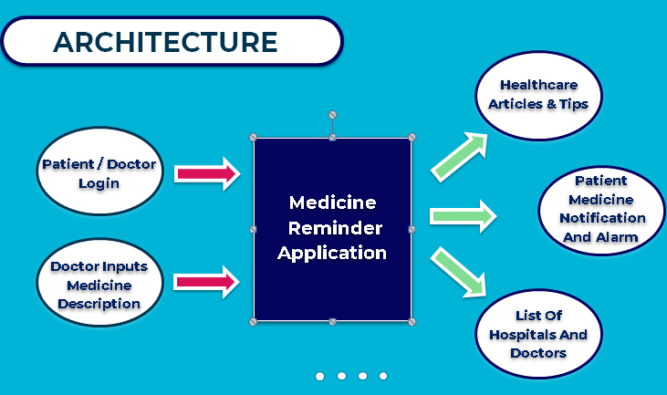

**4.4 USER INTERFACE AND DESIGNS**

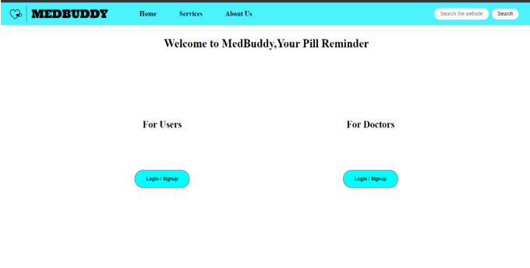

**CHAPTER 5**

**TECHNICAL IMPLEMENTATION & ANALYSIS**

5**.1 OUTLINE**

First thing after opening our web application “Med Buddy” we see is the login page for both patient and doctors. The user has to select the option according to it’s role.

Lets say we choose to login as patient ,then we are taken to the patient’s sign up page or if we already have an account we can simply to login.

After login in we are taken to the patient’s home page, here patient can describe his/hers illness or symptoms in the provided segment and choose the severity of the symptoms from mild, moderate, severe, very severe. After describing your symptoms and severity we have to submit it, doing this will send it to the doctor.

After that all the patient has to do is be patient until the doctor writes a prescription according to their symptoms and send it to the patient with all the reminders for medication being added to its reminder segment .

To sign or login in as a doctor the procedure is same as for patient ,at the doctor’s home page it would display the list which contains the details of patients illness.

Doctor can give prescription to the patient and reminders would be added for the patient as per the medication prescribed.

**5.2 LAYOUT**

Home page

Doctor

Patient

Doctor signup and login page

User signup and login page

Description of symptoms and illness

Doctor home page

Patient home page

Prescription of the medication

**Reminders**

**5.3 TECHNICAL CODING AND CODE SOLUTION**

Java script function for sign in into doctor’s home page

function signIn(e) {

let email = document.getElementById('email').value, pwd = document.getElementById('pwd').value;

let doctorData = JSON.parse(localStorage.getItem('doctorData')) || [];

let exist = doctorData.length &&

JSON.parse(localStorage.getItem('doctorData')).some(data => data.email.toLowerCase() == email && data.pwd.toLowerCase() == pwd);

if(!exist){

alert("Incorrect login credentials");

}

else{

doctorData.forEach((element,index) => {

let el = element.email,

pd = element.pwd;

if(el===email && pd===pwd)

{

localStorage.setItem("currDoctorIndex",index);

location.href = "DoctorHomePage.html";

}

});

}

e.preventDefault();

}

This Java script function is to add container for reminder in reminder section in home page of patient and also sends the reminder according to the frequency selected.

function divMaker(contents) {

var div = document.createElement("div");

var h2_medication_name = document.createElement("h2");

var p_due_time = document.createElement("p");

div.className = 'reminders'

div.setAttribute('style',"height: 7rem ; width:15rem;")

h2_medication_name.setAttribute('style', "font-weight: bold;")

h2_medication_name.innerHTML = contents.medName

p_due_time.setAttribute('style', 'margin-top:10px')

p_due_time.innerHTML = `Your medicine is due at <strong>${contents.firstIntake.substr(0,contents.firstIntake.lastIndexOf(':'))}</strong>`

div.appendChild(h2_medication_name)

div.appendChild(p_due_time)

const reminderBox = document.querySelector(".reminderBox")

reminderBox.appendChild(div);

var index = contentArray.indexOf(contents)

if (Notification.permission !== "denied") {

Notification.requestPermission();

}

var timeGap=contents.reminderTime/60

var originalhour=parseInt(contents.firstIntake.split(':')[0])

var originalMinute=parseInt(contents.firstIntake.split(":")[1])

var frequency = contents.frequency;

var variable = setInterval(() => {

console.log("AHSAJKDA")

if (frequency != 0) {

const notification = new Notification("New Notification From MedBuddy!", {

body: `Its Time to Take ${contents.medName}`

})

frequency--;

originalhour+=parseInt(timeGap/60)

originalMinute+=parseInt(timeGap%60)

const d = new Date();

d.setMinutes(originalMinute);

d.setHours(originalhour);

var help=d.toLocaleTimeString();

help=help.substr(0,help.lastIndexOf(":"))

p_due_time.innerHTML = `Your ${contents.medName} is due at <strong>${help}</strong>`

}

else

{

contentArray.splice(index,1)

localStorage.setItem("meds",JSON.stringify(contentArray))

reminderBox.removeChild(div)

clearInterval(variable);

}

}, contents.reminderTime * 1000);

}

**CHAPTER 6**

**PROJECT OUTCOME AND APPLICABILITY**

**6.1 KEY IMPLEMENTATION AND OUTLINE OF THE SYSTEM**

For making the project we have implemented the concepts of html, css and javscript, The website uses basic features provide by HTML such as forms, anchor tags etc. Forms have been used to collect the information of the Patient/Doctor such as their name,email etc all these data are further used to to login into he system. Also the forms have been used to input the patients problems and also the medication suggested by the doctor. CSS has played a major role in making the project in giving the simple and minimalistic design to the website. In Javascript, local storage is used to collect all the data and maintain a connection through the website.

* 1. **SIGNIFICANT OUTCOMES OF THE PROJECT**

**User friendly**: There is no requirement of technical background to operate this application.

**Free of cost**: Unlike the other applications it is free of cost.No money boundary will ever interfere with you in using the features of the application.

**Quite efficient:** This application not only saves your money but also your precious time if you are a busy scheduled person.

**6.3 PROJECTS APPLICABILITY AND OTHER APPLICATIONS**

Other medicine selling applications like-Pharmacy can use our app to inform the patient about the availability of those prescribed medicines at their online store when it gets over.

In fact, any website or app which deals with medication can inculcate the features of our website to provide a better user experience

**CHAPTER 7**

**CONCLUSION AND RECOMMENDATION**

**7.1 CONCLUSION**

MedBuddy, in its present state of development uses a reliable front-end framework which provides optimal functionality so as to ensure the patients never forget their medicines and prescription and can access them whenever it is time without fail. As noted earlier, different applications and websites can add our structure to their framework to satisfy their own quality of service requirements.

**7.2 LIMITATIONS OF THE PROJECT**

Currently, MedBuddy supports only the activites on the client side. We have not yet added the database and online servers. i.e one can only use the website at their end and response from any other person is not possible. Since the website uses local storage there is a chance of the user to accidently delete the data stored on the client pc. Also the use of notifications (provided by the Javascript), has limited the reminders of the medicines to pop up while the user is active on the website.

**7.3 FUTURE ENHANCEMENTS**

As pointed earlier, the use of local storage has limited our website access to a particular user. So for the future we have plans to add a database so that the website can be easily put under commercial use. Also by the use of database and facilities provided by NodeJs and Firebase we have a secure login system and notifications/reminders can be sent easily to the user mobile phone or to their email.

**REFERENCES**

1. <https://developer.mozilla.org/en-US/docs/Web/API/notification>
2. <https://developer.mozilla.org/en-US/docs/Web/API/Window/localStorage>
3. <https://developer.mozilla.org/en-US/docs/Web/API/Document_Object_Model/Introduction>
4. <https://developer.mozilla.org/en-US/docs/Learn/JavaScript/Objects/JSON>
5. <https://getbootstrap.com/docs/5.1/components>
6. <https://www.w3schools.com/>